**SALES TRENDS AND PROFIT REPORT**

* 1. **Define Objectives and Scope**:
* Clearly define the objectives of your analysis. looking to identify overall sales trends, analyse performance by product category, or evaluate sales by Product and Country.
  1. **Data Collection and Preparation**
* Identify the relevant data sources for your analysis, such as sales transactions, customer information, and product data. Ensure that the data is clean, complete, and accurate.
* Import the data into Power BI using get data which is store in my local disk.
* Perform any necessary action to clean but data is clean and all the relative information is found. But the State column is missing
  1. **Visualization Design**
* Choose the appropriate visualizations to represent your sales trends data effectively. Common visuals for financial sales trends show through line and stacked column chart.
* Design reports that provide an overview of sales performance by product and country as well as detailed insights into specific aspects of your business.

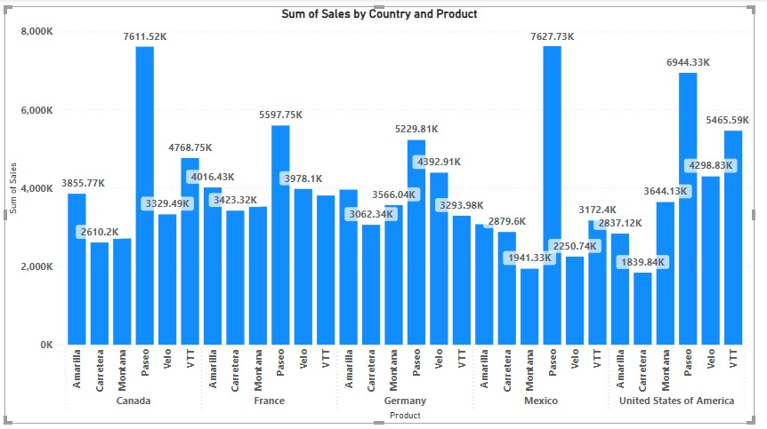

* 1. **Performance**
* In this Visualization found as more sales happen in Mexico and low sales happen in United states of America.
* As well as the product Paseo is high selling and low product sales is Carretera.
  1. **Interactivity**
* The dashboard is designed to be interactive, allowing users to explore data dynamically.
* Features like all the data labels shows and if we take the mouse cursor in bar then shows how much sales will happen in which country, enhance user experience and facilitate data analysis.
  1. **Conclusion**

This documentation provides a comprehensive overview of our financial sales trend’s analysis methodology in Power BI.

**PROFIT TRENDS**

**2.1** Same Data using making report so same insight will get but here I need to shows Profit trends .

**2.2 Visualization Design**

Overview of visualizations used to present profit trends.

Examples of using Area Chart .

Interpretation of visualizations to identify trends and patterns.

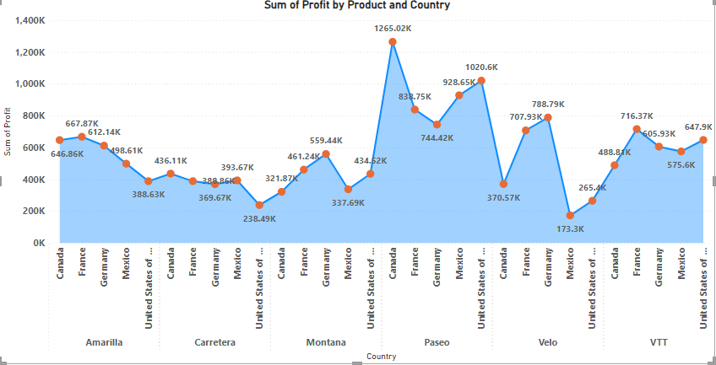

**2.3 Performance**

* Canada sum of profit is high and by selling of Paseo product.
* Lowest sum of profit is Mexico by selling velo product.

**2.4 Interactivity**

Recommendations based on profit trend analysis.

Strategies for improving profitability and mitigating risks.

**2.5 Conclusion**

Summary of key findings from profit trend analysis.

Importance of ongoing monitoring and analysis of profit trends for informed decision-making.